ENGSCI 9510L Case Study
Hailin Wang, Pengyi Jia, Xinyu Yun

Project Introduction
  - Overview of Bayer HealthCare – Organization and strategy
  - IT Organization at Bayer
  - Overview of The CRM program
前三部分按文档里的改写
  - Typical Life cycle introduction
看篇幅是否需要加上这部分凑数，可以整个项目计划之类的

Lessons Learned: coping strategies
  - Overall introduction and category
Table 1
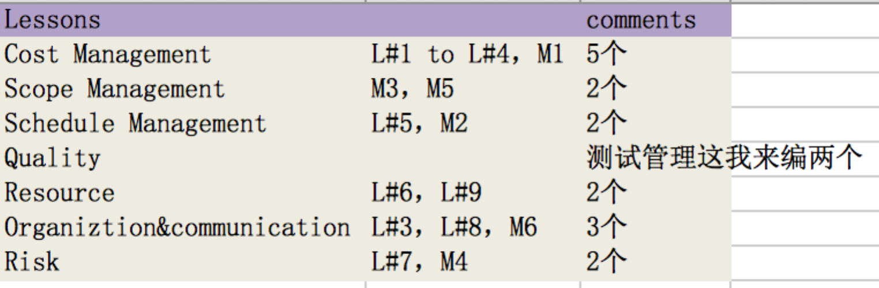
L# 和M的内容可能有重合，可以对照一下，合理发挥

